IR SENSOR

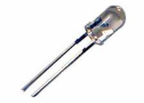
An IR LED, also known as IR transmitter, is a special purpose LED that transmits infrared rays in the range of 760 nm wavelength. Such LEDs are usually made of gallium arsenide or aluminium gallium arsenide. They, along with IR receivers, are commonly used as sensors.
The appearance is same as a common LED. Since the human eye cannot see the infrared radiations, it is not possible for a person to identify whether the IR LED is working or not, unlike a common LED. To overcome this problem, the camera on a cell phone can be used. The camera can show us the IR rays being emanated from the IR LED in a circuit.

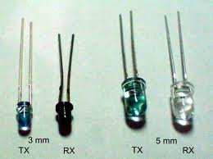

Pin Diagram:
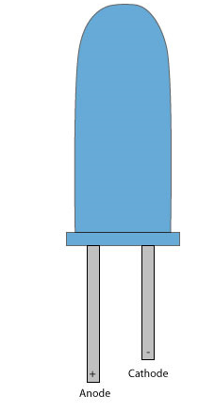

Analog and Digital Sensors:
There are two basic types of sensors: analog and digital. The two are quite different in function, in application, and in how they are used with the RoboBoard. An analog sensor produces a continuously varying output value over its range of measurement. For example, a particular photocell might have a resistance of 1k ohm in bright light and a resistance of 300k ohm in complete darkness. Any value between these two is possible depending on the particular light level present. Digital sensors, on the other hand, have only two states, often called "on" and "off." Perhaps the simplest example of a digital sensor is the touch switch. A typical touch switch is an open circuit (infinite resistance) when it is not pressed, and a short circuit (zero resistance) when it is depressed.

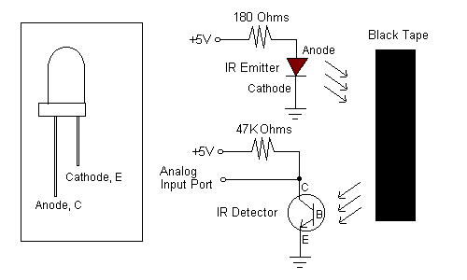
Some sensors that produce a digital output are more complicated. These sensors produce pulse trains of transitions between the 0 volt state and the 5 volt state. With these types of sensors, the frequency characteristics or shape of this pulse train convey the sensor's measurement. An example of this type of sensor is the Sharp modulated infrared light detector. With this sensor, the actual element measuring light is an analog device, but signal-processing circuitry is integral to the sensor produces a digital output.

